COURSE NAME: Theory of Computation COURSE CODE: CSA13

COURSE OUTCOME COVERED

CO2: Deign Finite Automata DFA, NFA, ε-NFA and demonstrate their equivalence for recognizing regular languages. (BL:3)

Assessment Tool Weightage: 20%

QUESTIONS: 5 Total Marks:50
Duration : 1 Hour

Scenario Based

Code of Conduct:

I K.Vsaudeva Reddy(192411256) (Name / Reg No) certify that this submission is my original work and that I have adhered to the guidelines specified for this assessment.
I understand that any violation of academic integrity rules will result in disciplinary action.

Signature of the student:


Question 1:
A company is developing a smart security system for a research laboratory. Every employee entering the lab uses a digital access card that generates a sequence of symbols:
- a → Valid ID scan
- b → Biometric verification
- c → Door access confirmation
The security rule states that:
- Every valid access sequence must start with a.
- It may contain any number of biometric checks (b).
- The sequence must end with c.
Examples of valid sequences: ac, abc, abbc, abbbc

Answer:
Symbols: a = Valid ID scan, b = Biometric verification, c = Door access confirmation.
Rule: every valid sequence must start with a, may contain any number of biometric checks (b), and must end with c.
Regular expression: a b* c
This says: exactly one 'a' at the start, followed by zero or more 'b's, followed by exactly one 'c'. It generates ac, abc, abbc, abbbc, ... exactly as required.
DFA design
States: q0 (start, waiting for ID scan), q1 (ID scanned, accepting biometric checks), q2 (accepting – door confirmed), qT (trap/reject).

State | a | b | c
q0 (start) | q1 | qT | qT
q1 | qT | q1 | q2
q2 (accept) | qT | qT | qT
qT (trap) | qT | qT | qT

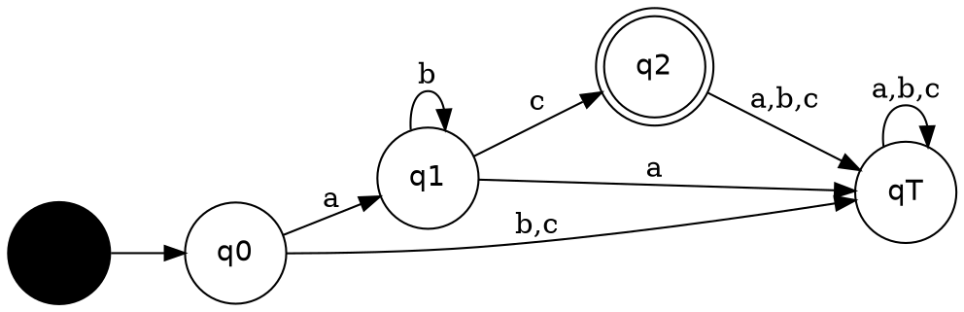

The single accepting state q2 is reached only after exactly the pattern a b* c has occurred, so the DFA accepts precisely the valid access sequences and rejects anything malformed (e.g. starting with b/c, or containing symbols after the door confirmation).

Question 2:
Given a DFA used for validating a specific PIN pattern bbbc, bca ,c, ca, caaaaaa minimize the DFA and explain how state reduction improves performance and efficiency in embedded systems

Answer:

The sample valid PINs given — bbbc, bca, c, ca, caaaaa — all fit one pattern: any number of b's, followed by exactly one c, followed by any number of a's. So the language being validated is:
L = b* c a*
Check: bbbc = b³c (0 a's), bca = b¹c a¹, c = b⁰ca⁰, ca = b⁰ca¹, caaaaa = b⁰ca⁵ — all match b*ca*.
Unminimized DFA (built directly from the sample strings)
If the DFA is first built as a straightforward path/trie recognizing each sample PIN separately (a common first-pass design), it ends up with a separate state for every prefix length of every sample string, plus a trap state — many more states than necessary:
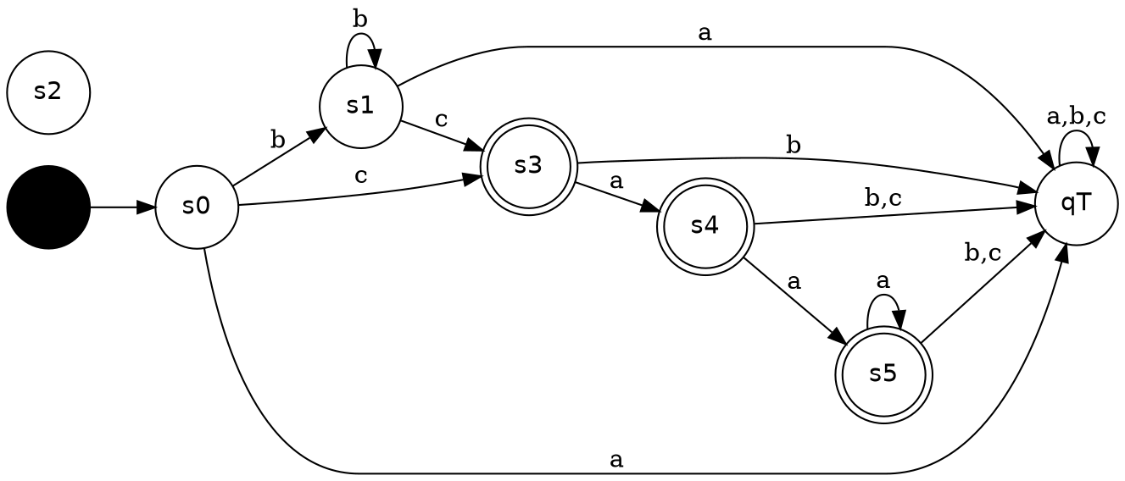
Minimization procedure (equivalence/partition method)
- Step 1 – Split states into accepting and non-accepting sets: F = {s3, s4, s5}, Q−F = {s0, s1, trap}.
- Step 2 – Refine each set: check whether all states in a group go to the same group on every input symbol.
- Step 3 – s0 and s1 both loop on b, both go to an accepting state on c, and both go to the trap on a → they are equivalent → merge into state A.
- Step 4 – s3, s4, s5 all self-loop/advance on a and go to trap on b or c → they are equivalent → merge into state B.
- Step 5 – No further splits are possible; the partition is stable.

Minimized DFA
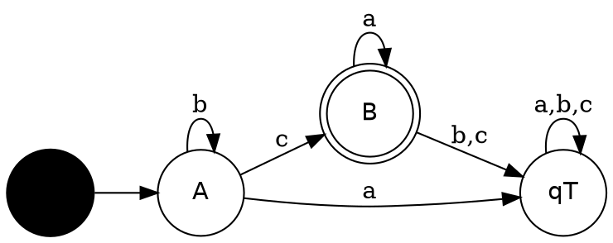

State | a | b | c
A (start) | qT | A | B
B (accept) | B | qT | qT
qT (trap) | qT | qT | qT

The minimized DFA has only 2 live states + 1 trap state instead of 6+ states, while accepting exactly the same language b*ca*.

Why state reduction matters in embedded systems:
- Lower memory footprint: fewer states means a smaller transition table, important on microcontrollers with limited RAM/flash.
- Faster lookups: a smaller table fits better in cache, so each symbol check is faster — important for real-time PIN/access validation.
- Lower power draw: fewer memory accesses and simpler logic reduce switching activity, extending battery life on embedded/IoT security devices.
- Easier verification and maintenance: a minimal DFA is simpler to test exhaustively and to prove correct, which matters for a security-critical component.
- Smaller hardware footprint if the DFA is synthesized directly into logic (FSM in an ASIC/FPGA) — fewer states means fewer flip-flops.

Question 3:
Demonstrate how a given finite automaton can be converted into a regular expression
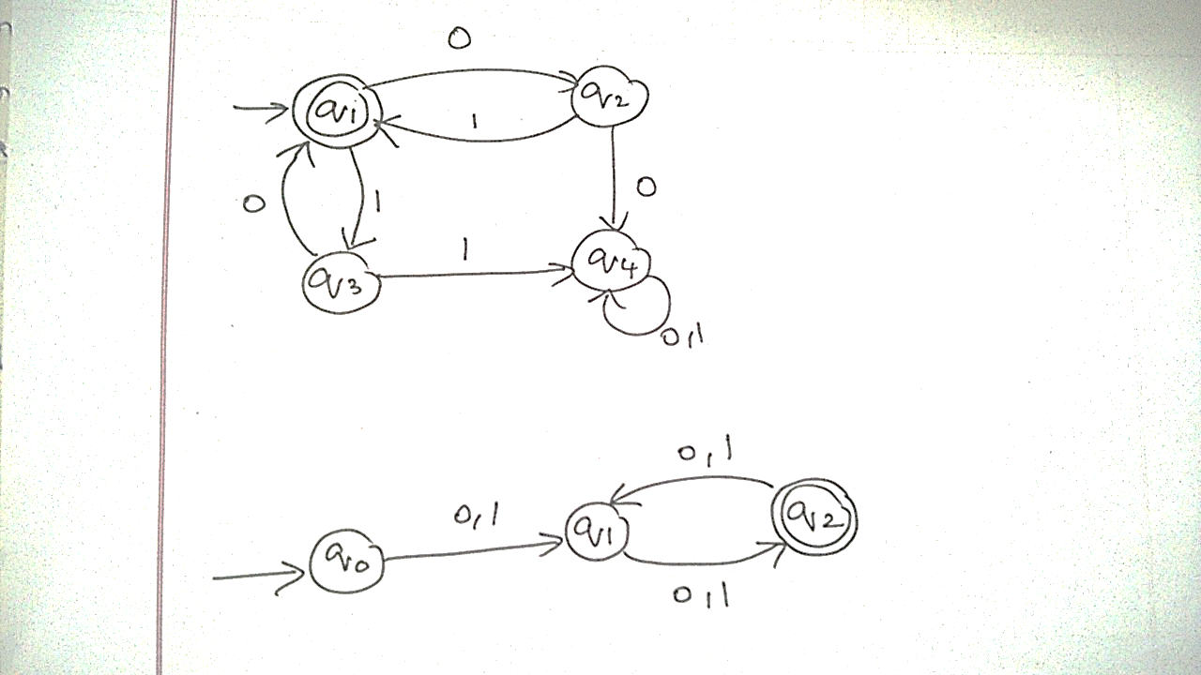
Answer:
Reading of the given diagram: q1 is the start state; q1 and q2 are connected by edges labelled 1 in both directions; q1 and q3 are connected by edges labelled 1 in both directions; q2 and q3 both go to q4 on 1; q4 has a self-loop on 1; q4 is the accepting state. (If any transition was misread, the same state-elimination/Arden's-Theorem method below applies — only the equations would change.)
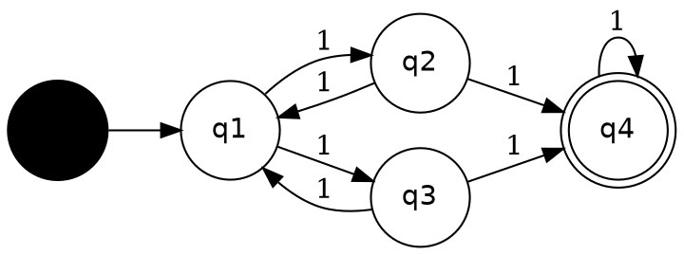
Method: Arden's Theorem
For each state qi let L(qi) be the set of strings that take the automaton from the start state q1 to qi. Arden's Theorem says: if R = Q + RP (with ε ∉ P), then R = QP*.
L(q1) = ε + L(q2)·1 + L(q3)·1 (q1 is start, and q2,q3 both feed back into q1)
L(q2) = L(q1)·1 (only q1 → q2)
L(q3) = L(q1)·1 (only q1 → q3)
L(q4) = L(q2)·1 + L(q3)·1 + L(q4)·1 (q2, q3, and q4 itself all feed q4)
Substitute L(q2) = L(q3) = L(q1)·1 into the first equation:
L(q1) = ε + (L(q1)·1)·1 + (L(q1)·1)·1 = ε + L(q1)·(11)
By Arden's Theorem (Q=ε, P=11):
L(q1) = ε·(11)* = (11)*
L(q2) = L(q3) = (11)*·1
Substitute into the L(q4) equation:
L(q4) = (11)*1·1 + (11)*1·1 + L(q4)·1 = (11)*11 + L(q4)·1
Apply Arden's Theorem again (Q = (11)*11, P = 1):
L(q4) = (11)*11·1*

Since q4 is the only accepting state, the regular expression for the whole automaton is:
R = (11)* 1 1 1*
This simplifies (the leading (11)* and trailing 1* together generate any number of extra pairs/singles of 1's) to:
R = 1 1 1* i.e. any string of 1's of length two or more.

General procedure demonstrated here (state elimination / Arden's Theorem):
- Write one equation per state, expressing it as the union of (predecessor language)·(symbol) for every incoming edge, adding ε if the state is the start state.
- Substitute equations for non-start states into each other until every state's language is expressed in terms of the start state and self-loops only.
- Apply Arden's Theorem to eliminate self-referencing terms (X = Q + XP ⇒ X = QP*).
- The union of L(q) for every accepting state q is the regular expression for the automaton's language.

Question 4:
Consider the following grammar
S->aSc|T|U|e
T-> bTc|e
U->aUb|e
A} What is the language defined by the grammar?
B) Give the derivation tree for the word aaabbc
C) Grammar is Ambiguous if there exists two distinct derivations for a word. Is the above grammar ambiguous? Justify.

Answer:

Grammar:
S → aSc | T | U | ε
T → bTc | ε
U → aUb | ε

A) Language defined by the grammar
T by itself generates {bᵐcᵐ : m ≥ 0} and U by itself generates {aᵏbᵏ : k ≥ 0}. S wraps n more a's on the left and n more c's on the right around either T, U, or nothing. So:
- Via S → ... → S → ε: aⁿcⁿ, n ≥ 0
- Via S → ... → S → T: aⁿbᵐc⁽ⁿ⁺ᵐ⁾, n,m ≥ 0
- Via S → ... → S → U: a⁽ⁿ⁺ᵏ⁾bᵏcⁿ, n,k ≥ 0
Overall, L(G) = { aⁱbʲcᵏ : i,j,k ≥ 0 and ( i = k or k = i + j or i = j + k ) }
In words: every string is of the form a's followed by b's followed by c's, where the a-count, b-count and c-count satisfy one of three balance conditions (#a = #c, or #c = #a+#b, or #a = #b+#c).
B) Derivation tree for aaabbc
For aaabbc: i(a)=3, j(b)=2, k(c)=1, and i = j + k (3 = 2+1), so this word is generated via the S → U branch with n = 1 (outer a...c pair) and k = 2 (aUb applied twice inside U).
S ⇒ aSc ⇒ aUc ⇒ a(aUb)c ⇒ aa(aUb)bc ⇒ aaa(ε)bbc = aaabbc
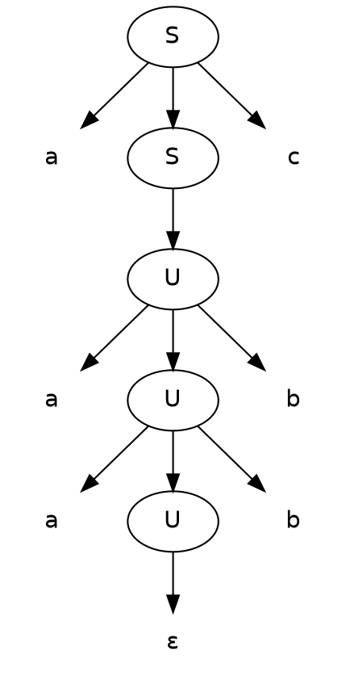
C) Is the grammar ambiguous?
Yes — the grammar is ambiguous. A grammar is ambiguous if some string has two or more distinct parse trees (or equivalently, distinct leftmost derivations).
Consider the empty string ε. It can be derived in three structurally different ways:
- S ⇒ ε (directly, using S → ε)
- S ⇒ T ⇒ ε (using S → T, then T → ε)
- S ⇒ U ⇒ ε (using S → U, then U → ε)
These are three distinct parse trees (different shapes/heights) that all yield the same string ε, so by definition the grammar is ambiguous.

Question 5:
I)Show that if L1 and L2 are regular then (L1+l2) also regular
Ii)Is the language { a^p| p is prime} regular? Justify

Answer:
I) If L1 and L2 are regular, then L1 ∪ L2 is regular
Proof (via NFA construction): since L1 and L2 are regular, there exist NFAs N1 = (Q1, Σ, δ1, s1, F1) and N2 = (Q2, Σ, δ2, s2, F2) such that L(N1) = L1 and L(N2) = L2.
Construct a new NFA N = (Q1 ∪ Q2 ∪ {s}, Σ, δ, s, F1 ∪ F2), where s is a new start state not in Q1 or Q2, and δ adds two ε-transitions: from s to s1 and from s to s2, in addition to all the transitions of δ1 and δ2 (state sets are kept disjoint by renaming if necessary).
Any string accepted by N must first take an ε-move to either s1 or s2 (there is nowhere else to go from s). If it moves to s1, N behaves exactly like N1 and accepts iff the string is in L1; if it moves to s2, N behaves exactly like N2 and accepts iff the string is in L2. Hence:
L(N) = L(N1) ∪ L(N2) = L1 ∪ L2
Since N is a finite automaton (with ε-transitions, which can always be removed to give an equivalent DFA), L1 ∪ L2 is accepted by a finite automaton and is therefore regular.
(Equivalently, since regular languages are closed under regex union: if r1 and r2 are regular expressions for L1 and L2, then r1 + r2 is a regular expression for L1 ∪ L2 — this is immediate from the definition of regular expressions.)

II) Is L = { aᵖ : p is prime } regular?
Suppose, for contradiction, that L is regular. Then the Pumping Lemma guarantees a pumping length n ≥ 1 such that every string w ∈ L with |w| ≥ n can be written w = xyz with |xy| ≤ n, |y| ≥ 1, and xyⁱz ∈ L for every i ≥ 0.
Since there are infinitely many primes, choose a prime p ≥ n and let w = aᵖ. Then w = xyz with |y| = k, where 1 ≤ k ≤ n (so 0 < k ≤ p).
By the pumping lemma, xyⁱz ∈ L for every i ≥ 0. In particular, take i = p + 1:
|xy^(p+1)z| = |x| + (p+1)|y| + |z| = (|x|+|z|) + (p+1)k = (p − k) + (p+1)k = p + pk = p(1 + k)
So the pumped string has length p(1+k). Since k ≥ 1, we have (1+k) ≥ 2, and since p ≥ 2, the number p(1+k) has two factors, p and (1+k), both ≥ 2 — so p(1+k) is composite, not prime.
But the pumping lemma requires a^(p(1+k)) ∈ L, i.e. p(1+k) must be prime. This is a contradiction.
Therefore our assumption is false, and L = { aᵖ : p is prime } is not regular.

RUBRICS FOR CALCULATION

Criteria | Weightage | Q1 (10) | Q2 (10) | Q3 (10) | Q4 (10) | Q5 (10) | Total Marks (50)
Conceptual Understanding | 30 | 3 | 3 | 3 | 3 | 3 | 15
Accuracy of Answer | 25 | 2.5 | 2.5 | 2.5 | 2.5 | 2.5 | 12.5
Application of Knowledge | 20 | 2 | 2 | 2 | 2 | 2 | 10
Completeness of Response | 15 | 1.5 | 1.5 | 1.5 | 1.5 | 1.5 | 7.5
Clarity & Presentation | 10 | 1 | 1 | 1 | 1 | 1 | 5
Total per Question | 10 Marks | /10 | /10 | /10 | /10 | /10 | / 50

